Wells Academy
Steubenville City Schools
Wonder Garden Supply List

1 book bag (please no mini bookbags)
1 box of crayons
1 box of markers
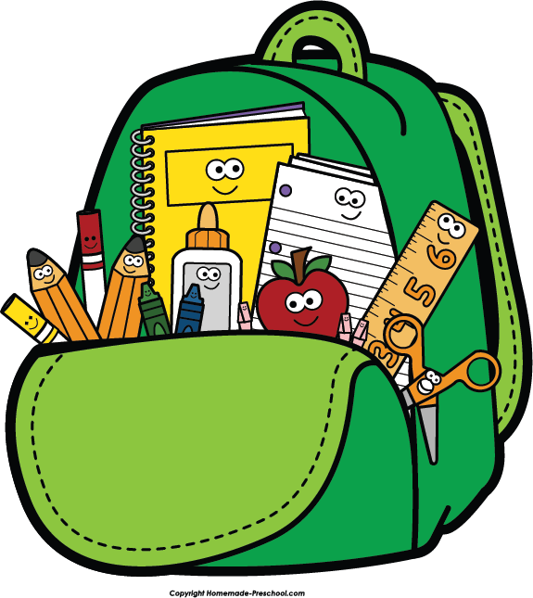
1 bottle of glue
4 glue sticks
1 package of regular sharpened pencils
2 containers of Clorox Table wipes
2 rolls of paper towels
1 pencil box
1 pack of Popsicle sticks
1 pack of straws
1 pack of Dixie cups
1 pack of tooth picks

